Some Most Important Basic Things of React-Js

- React-Js se Project banane se pahle hame data ke baare me sochna padta hai use extract ya collect karke samagj ke store karna padta hai phir usi data ko use karna padta hai jab ham components banate hai usi me send karna padta hai as : props and state.

- Data: data like agar ham koi profile cards bana rahe hai to iske liye data hoga user ka name, age, imageUrl, jobRole, Gender etc jo ham components me use karne wale hai according to project requirements.

- Hame sochna padta hai ki data ko store kaise kare taki components ko easily send kar sake in the form of props. Generally Data object “{}” form me store hota hai “{}” iske ander. Lekin jab data jyada hota hai to ham ise “list of object” form me store karte hai phir list ko iterate kara ke each object ko props ke form me components ko send kar dete hai ok ..... baad me ham inhi data ko database se api ke form me access kar ke components ko send karte hai ye ham baad me padhenge pro level me .

- Or jab repitative task jaise profile cards ke liye components banate hai n to waha “div” nhi use karte “li” list use karte hai unorderd list use karte hai “ol”.

- Please observe all the below images for clear understanding.

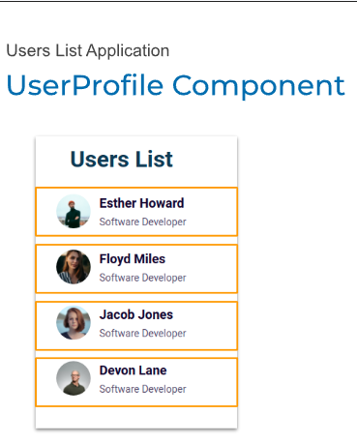
- UserProfile component banega sirf ek card ka code likha jayega userProfile component ke ander. ok only single card.

- “div” ki jagah “li” use kiya jayega kuki repititive task hai

- Is User List ko complete develope karne ke liye iska data prepare kiya jaygea store kiya jayega list of object ke form me phir UserProfile component ko baar baar import karke ya loop chale ke ya predefined function use karke jaise array.map() list of data ko UserProfile component me data as a props send kiya jayega.

- Bas hamari user list ban ke ready ho jayegi ise render kar ke live kar lenge. Project ready !

Now Look
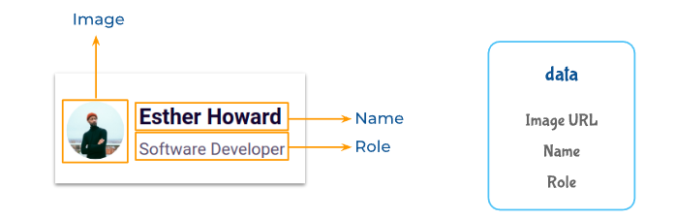
- figma ui design of UserList ko observe kiya gaya ek card select karke data pattern dekha gaya same tha ok to.

- Data: data prepare kiya hmm.

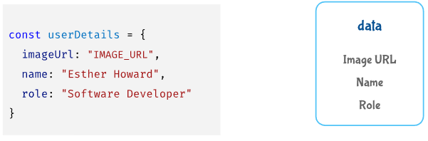
- Data ko store kiya gaya object form me sirf single card ccomponent banane ke liye.

- Data ko ProfileCard component me as a props send karke ek card bana liya gaya but...

- Hame to dher saare profile cards banane the

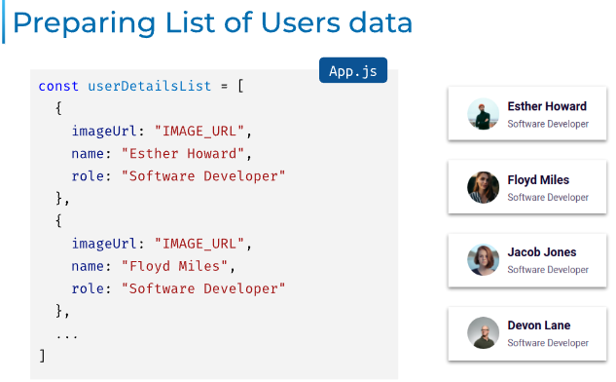
- do raste the 1st: alag alag users ke data ko alag alag object form me store karte or send karte component ko isme jyada code likhna padta har user ke liye baar bar ProfileCard component ko call karna padta usme manually props send karne padte. Bada long code ho jata.

- 2nd rasta: Ham saare data ko kuch is prakar list ke ander rakh deta object form me or list ko iterate karwa dete loop ka use karke ya builit function ka like map() so

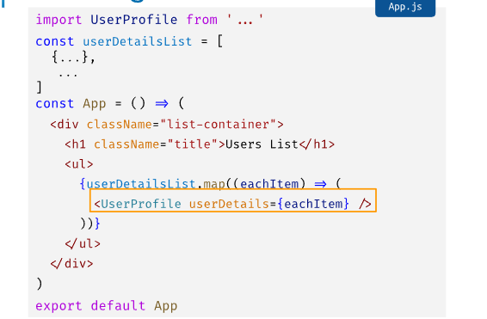
- Hamne wahi kiya userDetailsList banai saara data object form me store karke only ek baar UserProfile component ko call kiya or har object ko isme send kar diya as props bas built in map() function ka use karke userDetailsList ko iterate kara ke.

- Ho gaya ban gai hamari user list render kiya or Ready Project !!

Ek Important Baat or

- har component ke ander minimum 2 files hoti hai ek index.js and 2sri index.css.

- component ke ander index.js wali file me index.css ko import karke styling ke liye use karte hai, styling ham jsx code ko karte hai jisse component banaye ja rahe hote hai.

Always Remember all These things ok

Date: Mar-1-2025

